# Website Links

Turing Link - <http://turing.algomau.ca/~swilding/>

notTuring Link - <https://notturing.ddns.net/tyler/IT_FProj/index.html>

Source Code Link - <https://github.com/xTVaser/Schoolwork-Fall-2016/tree/master/Internet%20Tools/Final%20Project/Source>

Pages that are pretty much complete:

* Homepage
* Media Page (only need canvas element)
* Friends Page
* Contact Page

Pages that just need content added:

* Projects
* Skills
* Articles
* About Me

Blog page is going to be removed, scrapped the idea.

# 

# Sitemap

Internet Tools Sitemap.png

# 

# 

# Wireframe

## Home

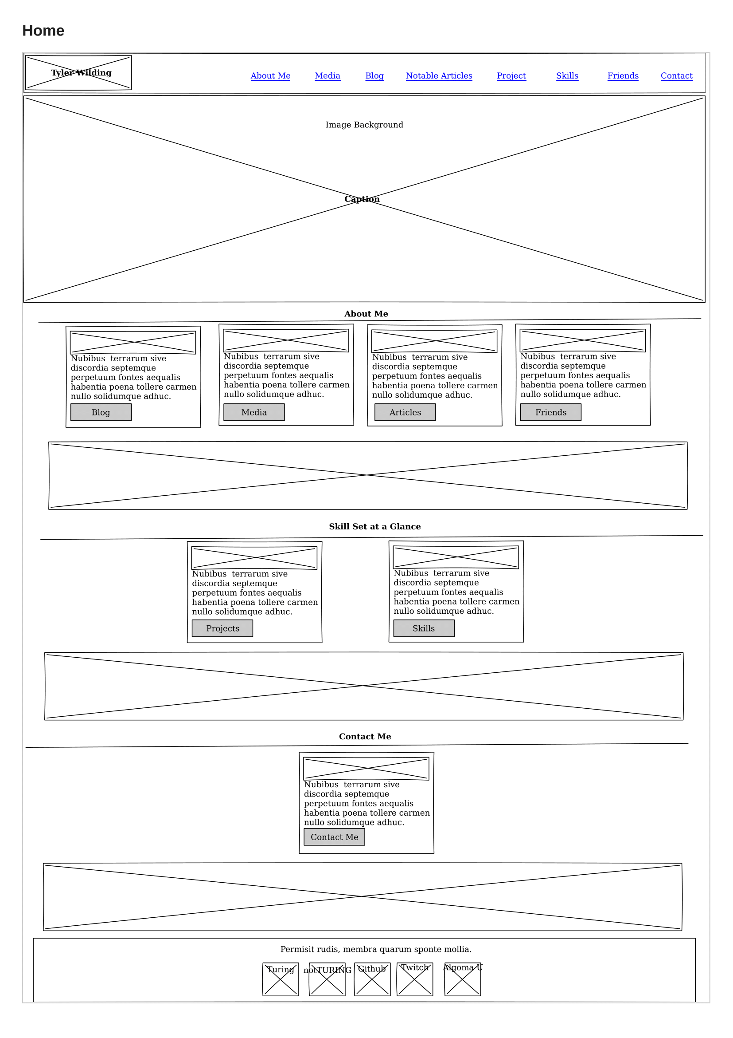

## About

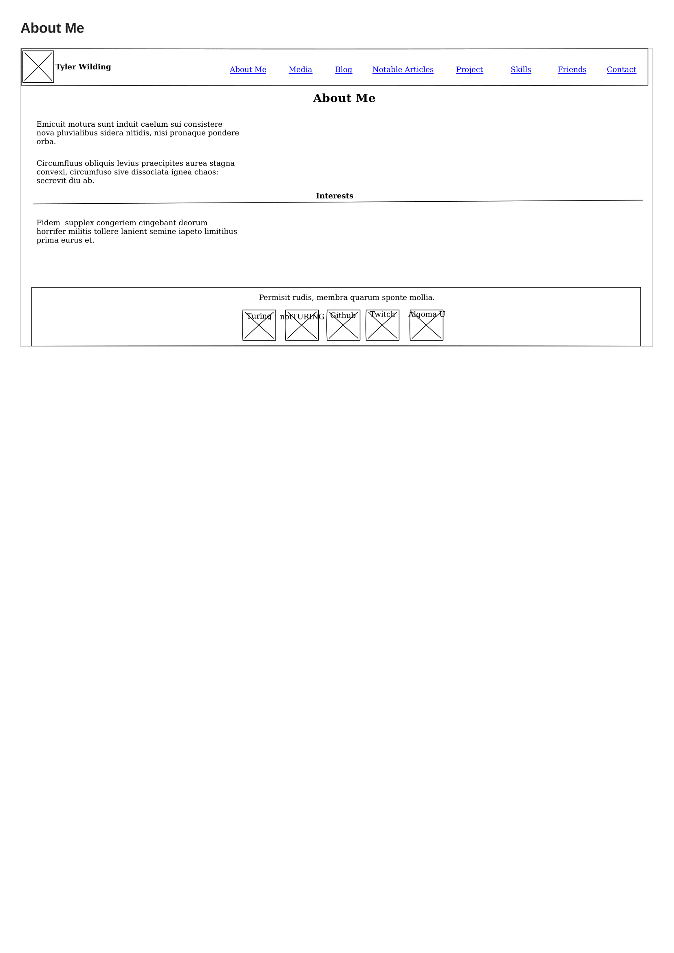

## Media

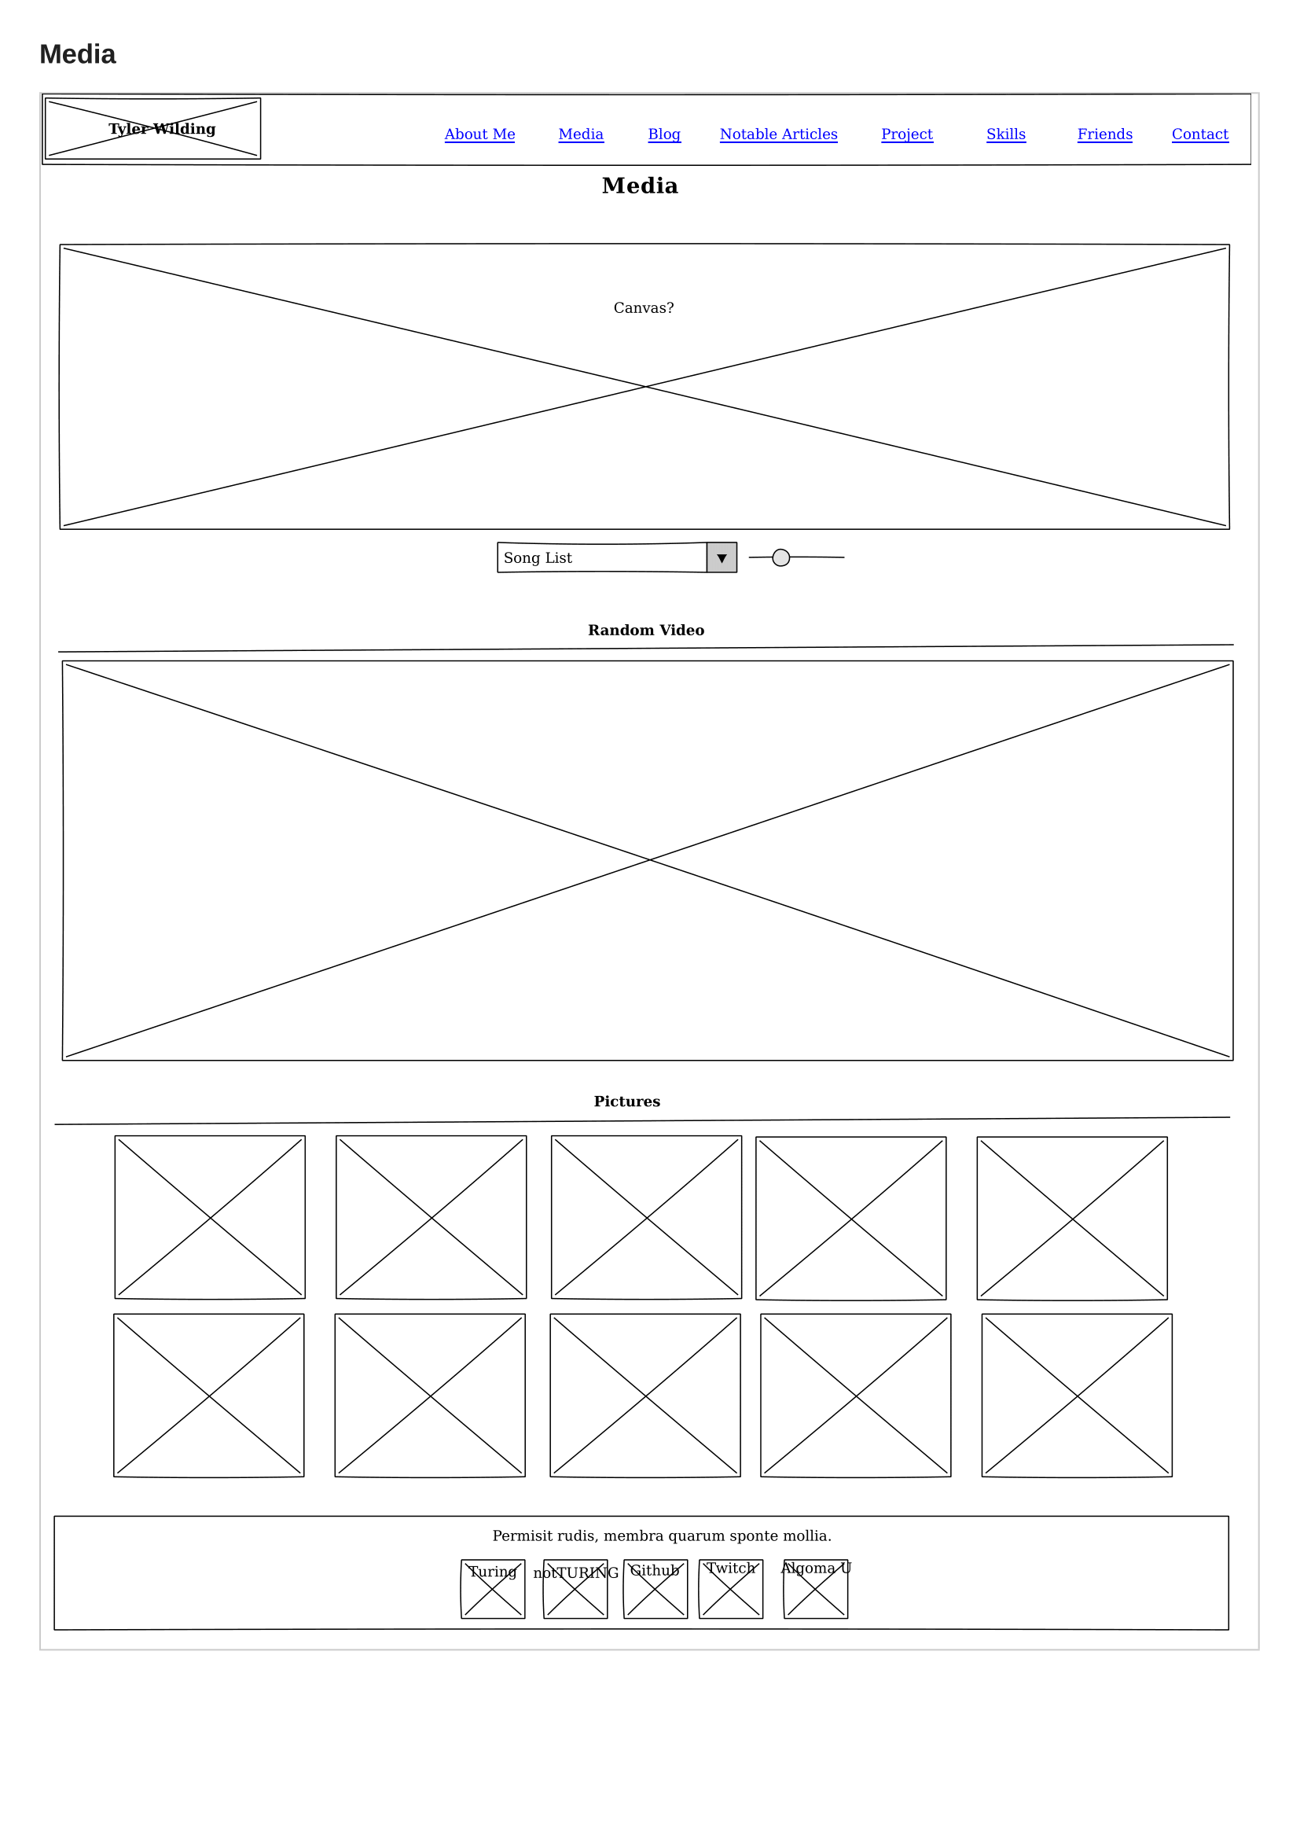

## Notable Articles

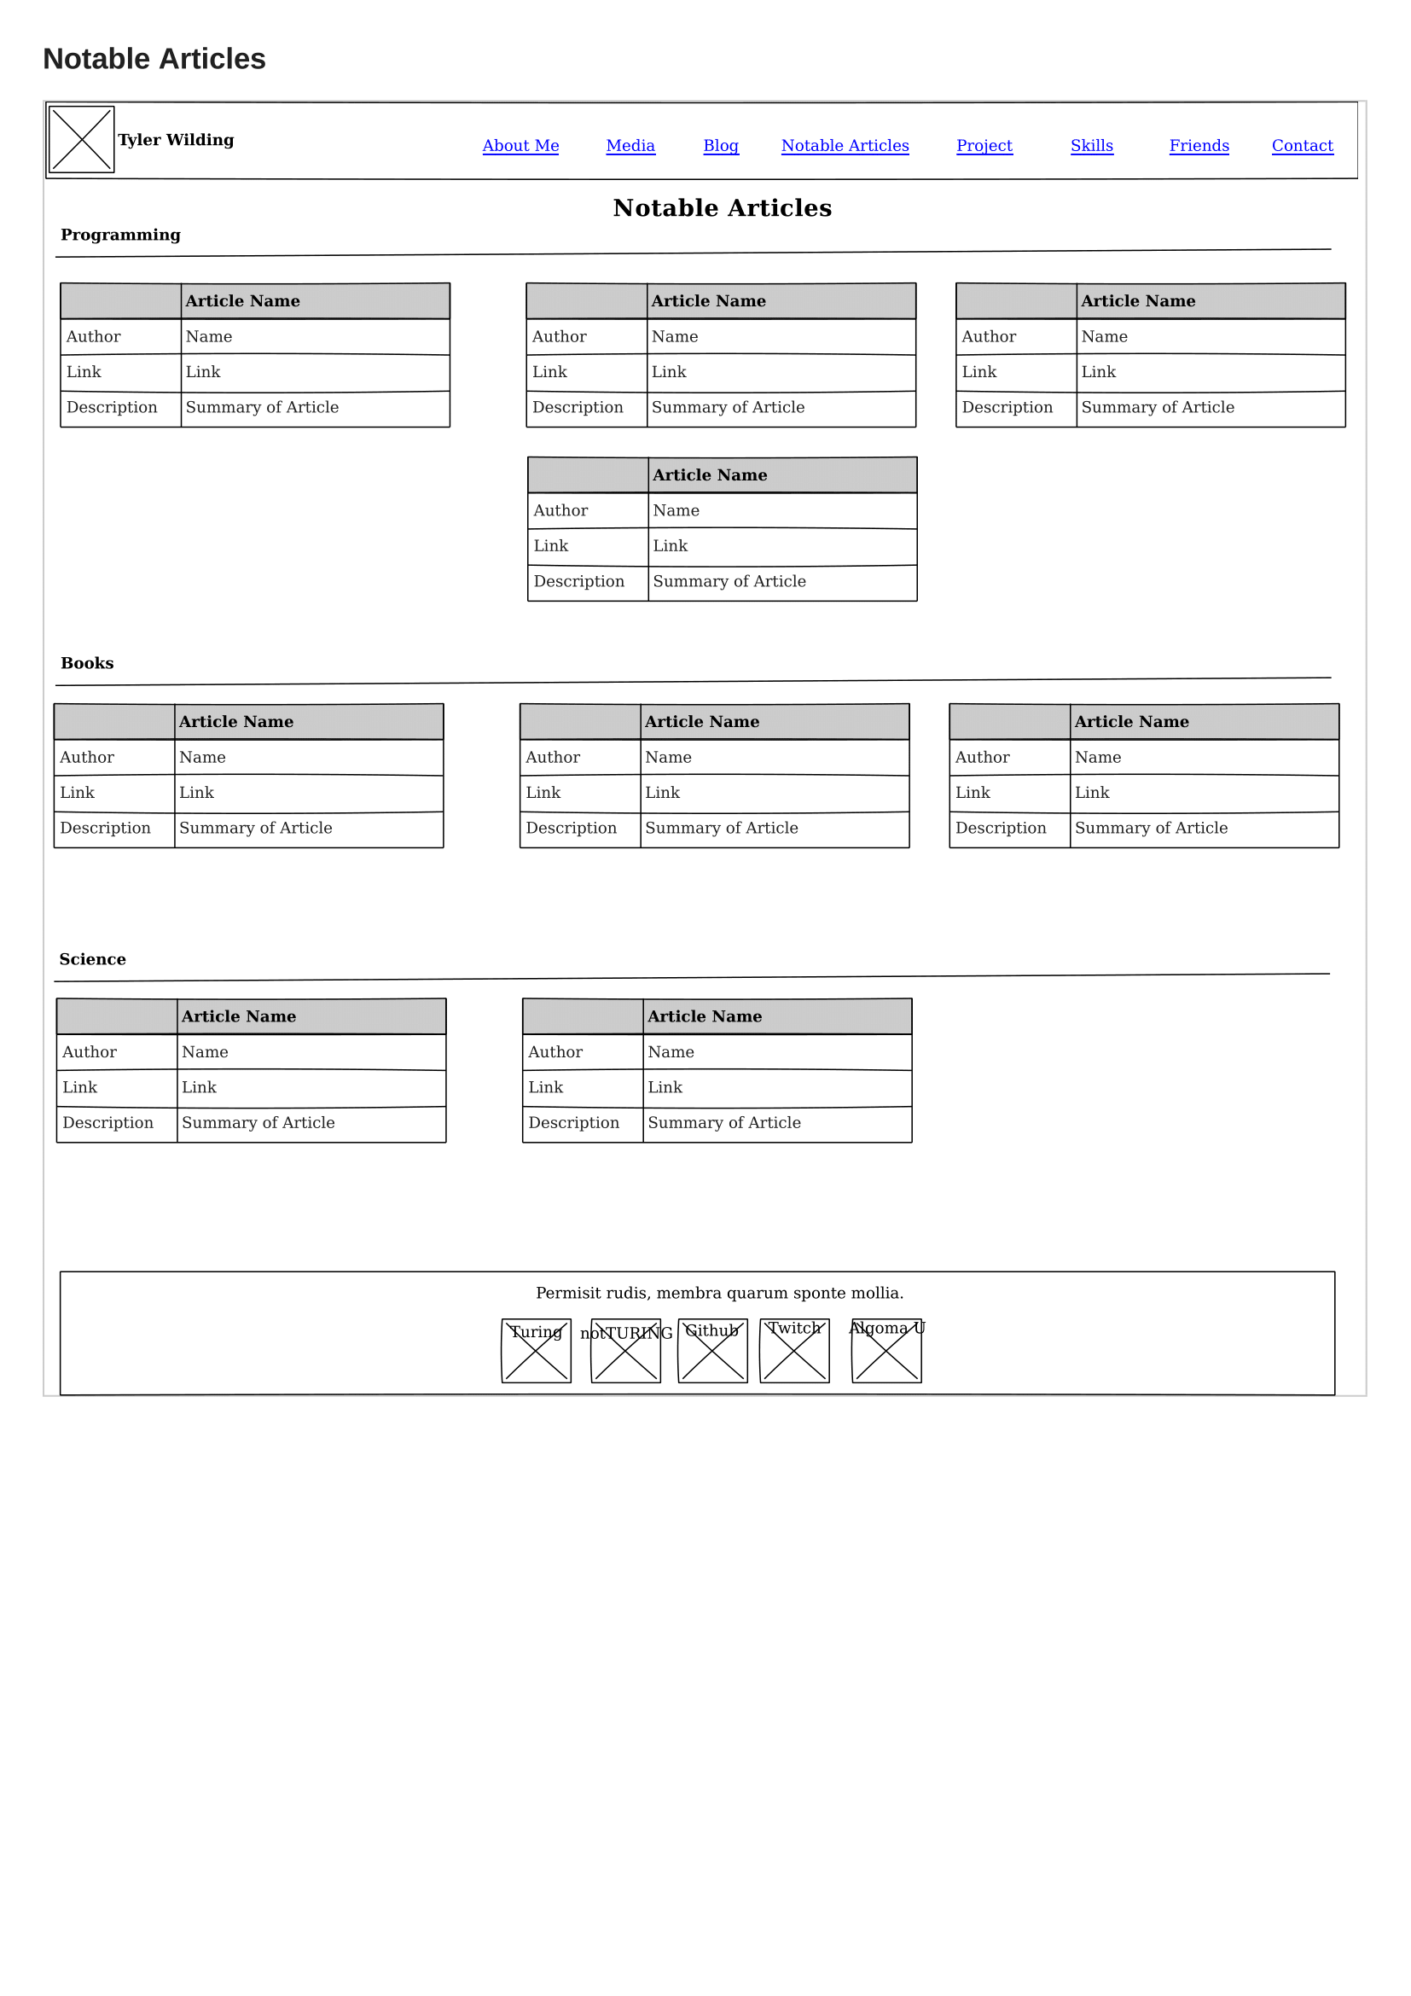

## Projects

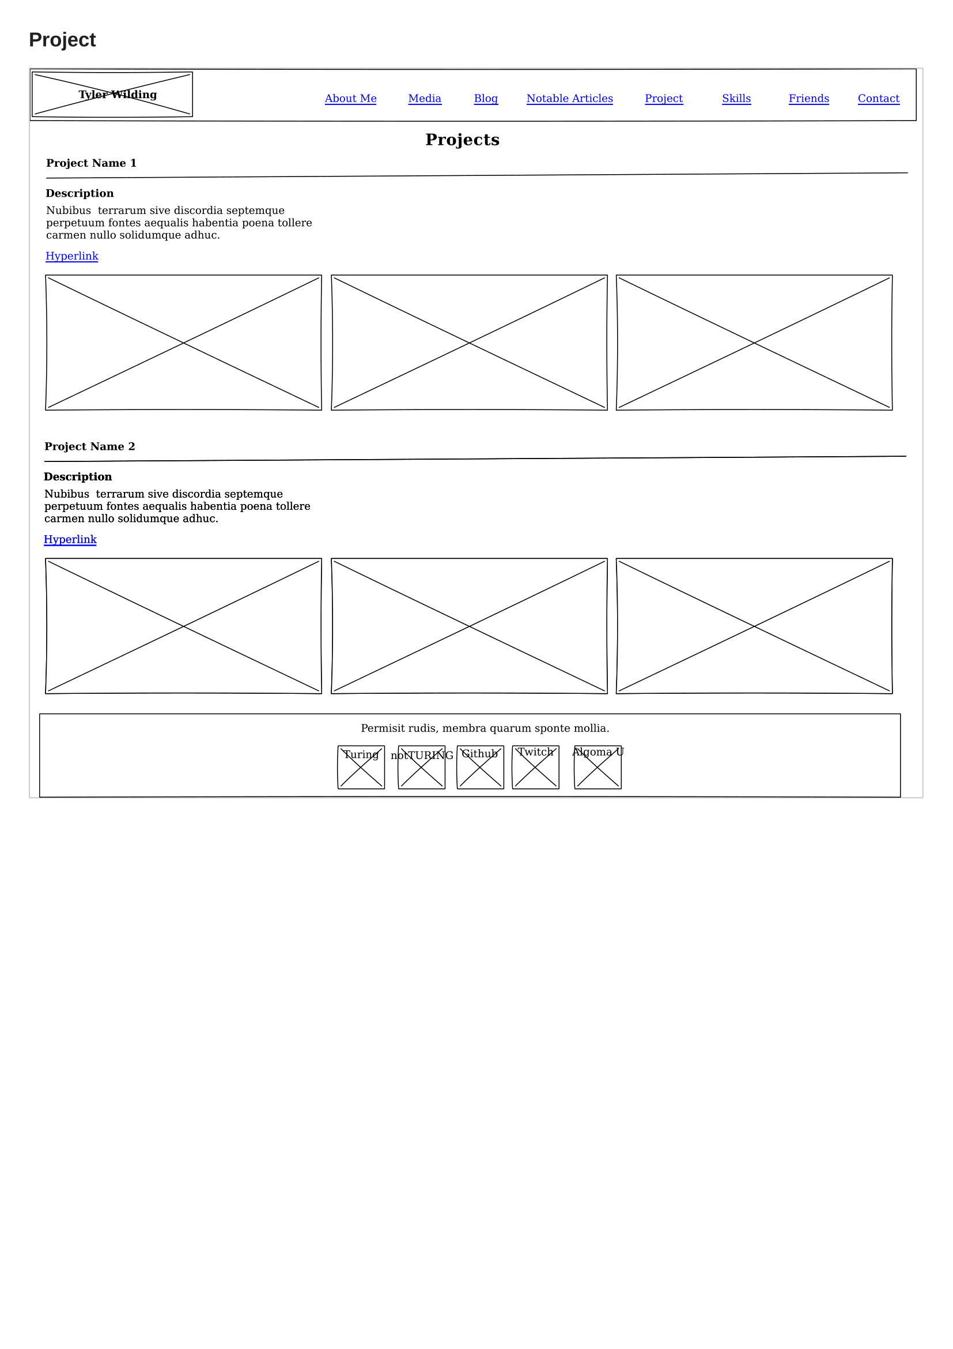

## Skills

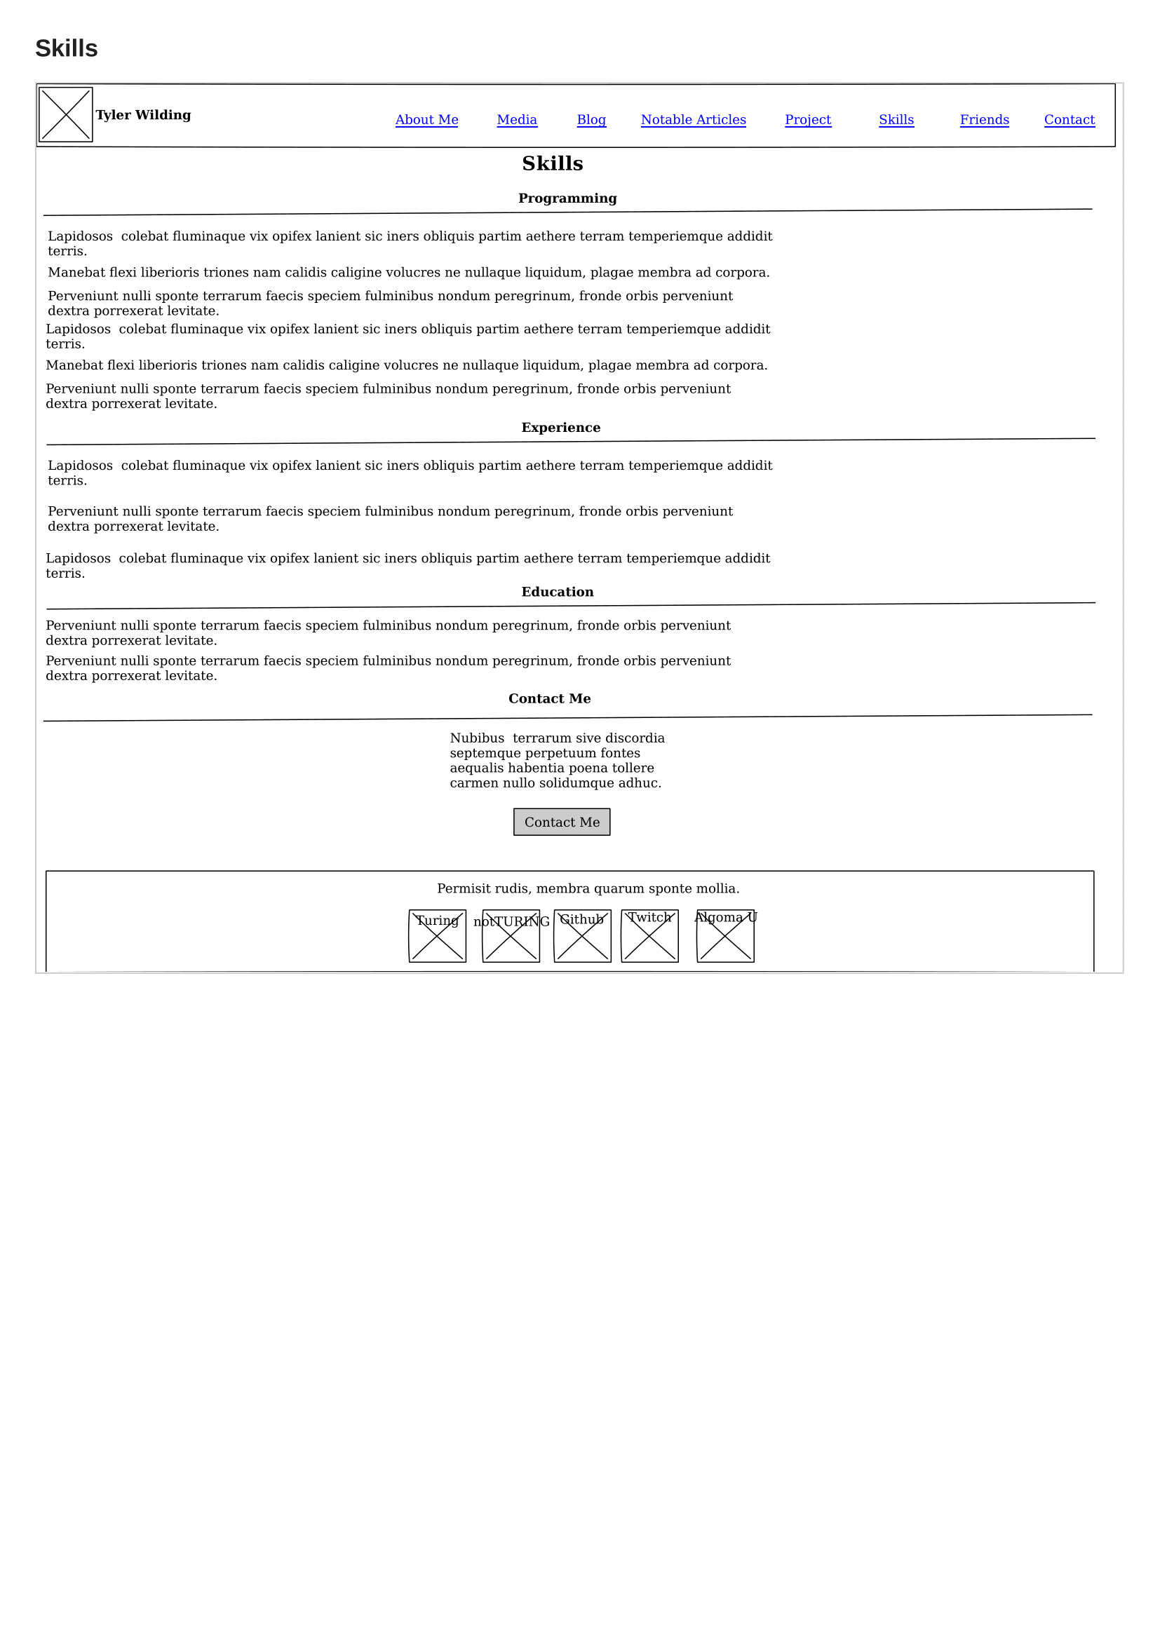

## Friends

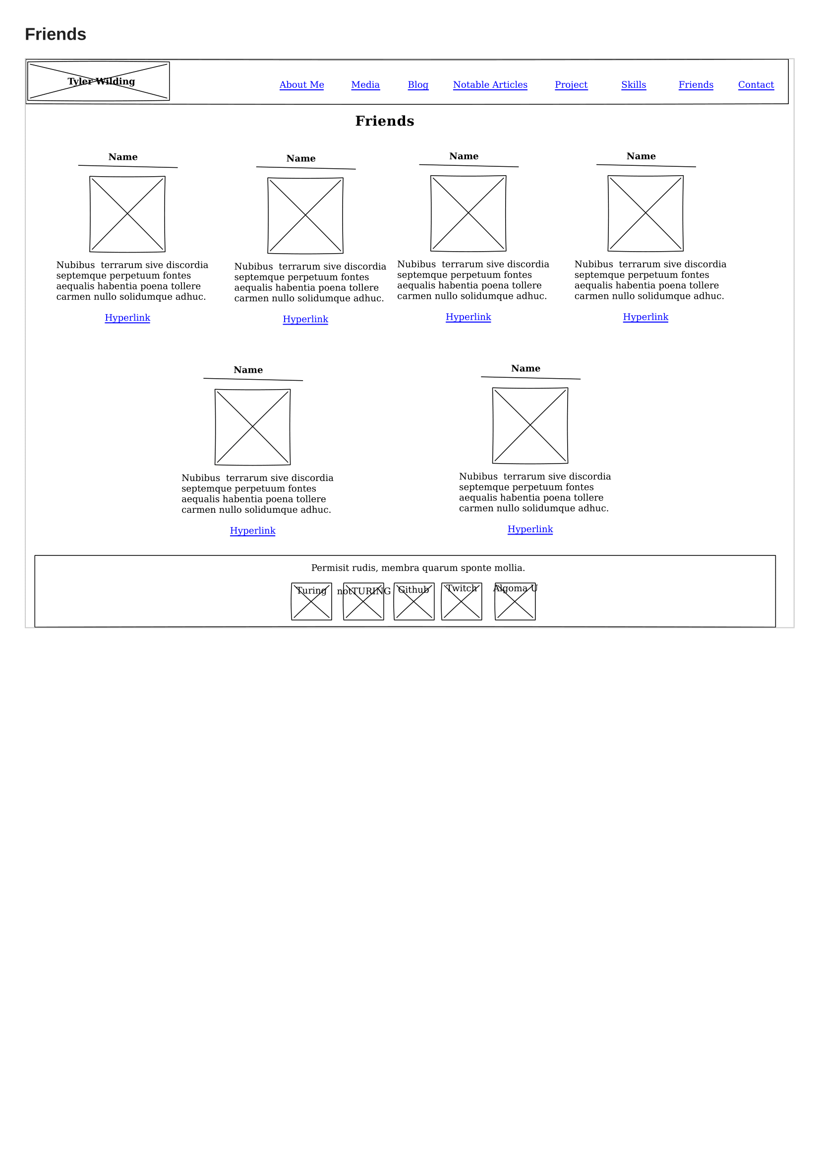

## Contact

